2020神经影像计算与人工智能云论坛
2020 Computational Medical Imaging and Artificial Intelligence Online Forum

Program

主 办 单 位
浙江工业大学信息工程学院
哈佛大学数学成像实验室
浙江大学生物医学工程与仪器科学学院
2020.07.22

简介
由浙江工业大学信息工程学院、哈佛大学数学成像实验室、浙江大学生物医学工程与仪器科学学院联合举办的“2020神经影像计算与人工智能云论坛”将于2020年7月22日召开。
云论坛主题主要包括：扩散磁共振成像中的数学问题、人工智能方法、临床应用等。
本次论坛将邀请国内外知名学者做主题演讲，旨在为国内医学影像领域工作者提供学术交流平台，增进了解，共谋发展。
诚邀海内外相关领域学者医生莅临指导！

Introduction
2020 Computational Medical Imaging and Artificial Intelligence Online Forum will be held on July 22, 2020, which is jointly organized by the College of Information Engineering, Zhejiang University of Technology, Laboratory for Mathematics in Imaging of Harvard University, and College of Biomedical Engineering & Instrument Science，Zhejiang University.
The main topics of Online Forum include: mathematical problems in diffusion magnetic resonance imaging, artificial intelligence and clinical applications.
This forum will invite domestic and foreign renowned scholars to give keynote speeches, aiming to provide an academic exchange platform for medical imaging field workers, to increase mutual understanding and make joint efforts. The presence and guidance of friends at domestic and abroad are wholeheartedly welcome.

Title: Deep Learning for High-quality Brain Microstructure Imaging
Abstract: Neurite morphology provides important information for the understanding of the human brain. Diffusion MRI offers a unique tool for in vivo investigation of neurite morphology and allows noninvasive assessment of the complex tissue microstructure. To provide sensitive and specific biomarkers for tissue microstructure description, various advanced biophysical models have been developed. However, since the relationship between the model parameters and diffusion signals in these models is usually complicated, the inference of the parameters and thus tissue microstructure is challenging with a limited number of diffusion gradients (e.g., in clinical dMRI scans). In addition, the quality of tissue microstructure estimation could also be limited by the low spatial resolution of dMRI. In this talk, I will discuss the development of deep learning based techniques for high-quality tissue microstructure estimation given diffusion signals undersampled in the q-space and with a low spatial resolution. The discussion will include several works from our group, which have been published in top journals and conferences, such as Medical Image Analysis, MICCAI, and IPMI. An outlook about future directions for deep learning based tissue microstructure estimation will also be given.
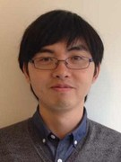
叶初阳，北京理工大学信息与电子学院副教授、博士生导师。2009年于北京大学信息科学技术学院获得学士学位，2014年于美国约翰霍普金斯大学电子与计算机工程系获得博士学位。研究方向为医学图像处理，特别是弥散磁共振图像处理和分析方法，包括神经束重建和脑连接计算方法、组织微观结构计算方法、解剖结构和病灶分割方法等。目前已发表SCI/EI论文三十余篇，其中以第一作者/通讯作者在医学图像处理领域顶级期刊Medical Image Analysis和顶级会议MICCAI、IPMI 发表文章十余篇。

Title:灵长类磁共振脑图谱的跨物种比较研究
Abstract: Psychiatric disorders often exhibit shared symptoms, raising controversies over accurate diagnosis and the overlap of their neural underpinnings. Because the complexity of data generated by clinical studies poses a formidable challenge, we pursue a highly reductionist framework using brain imaging data of transgenic non-human primate model of autism spectrum disorder (ASD). Here we report an interpretable cross-species machine learning approach which extracts transgene-related active regions in the monkey brain to construct the classifier for diagnostic classification in humans. This monkey-based classifier outperformed human-based classifiers in both ASD and obsessive-compulsive disorder (OCD) cohorts, which further allows to dissect differential connections to the right ventrolateral prefrontal cortex attributable to distinct traits in patients with ASD and OCD. We demonstrate that active regions learned from genetically-engineered monkeys enable a pathological dissection of etiologic overlap cross human ASD-related diseases, informing an evolutionarily conserved mechanism that lays the groundwork for developing artificial intelligence-based psychiatric diagnosis. In this talk, we will specifically discuss some potential effects caused by anesthesia to brain connectomics in monkeys and how it would affect the connectomic comparisons between these two primate species.
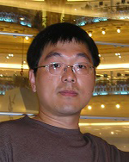
王征 博士，中国科学院脑科学与智能技术卓越创新中心研究员，博士生导师，中国科学院引进杰出技术人才。长期以来一直从事发展高场磁共振成像和神经调控技术，结合非人灵长类疾病动物模型，开展临床神经精神类疾病特别是情感障碍类疾病机理和干预手段方面的研究。申请发明专利和软件著作权等5项，在国际知名学术期刊发表相关研究论文30余篇，包括Science、Neuron、Am J Psychiatry、Biol Psychiatry、J Neurosci、Cereb Cortex、IEEE TMI等。先后主持或参与承担了中科院3.0T和9.4T动物磁共振成像系统、中科院先导科技专项、科技部重点研发计划、基金委国家重大科研仪器设备研制和面上项目、上海市科技重大专项、美国国立卫生研究院R01等相关科研任务，担任科技部、基金委等国家和多个省部级的科研项目，以及长江学者、青年千人、优青等人才项目的评审专家。

Title: Asymmetric fiber trajectory distribution estimation and fiber tracking using higher order streamline differential equation
Abstract: Fiber tracking which based on diffusion magnetic resonance imaging (dMRI) is an important method to investigate the white matter structure of living brain. Current fiber tracking methods based on Euler's method for solving Frenet first order differential equations are prone to cause multiple problems, such as fiber interruption in the white matter, intertwined fibers, false fibers, and inability to accurately describe the asymmetric fiber geometry, such as bifurcations, bottlenecks, fan shapes, and large bends. Asymmetric fiber orientation distributions (AFODs) based method to describe complex asymmetric fiber structure has been improved these situations to a certain extent. However, simply plugging these AFODs into a typical tractography paradigm continues to face ambiguous spatial correspondences. With the progress of brain science, researches intuitively observe that nerve fibers exist in the form of streamline clusters from the micron level. Here we report an asymmetric fiber trajectory distribution estimation and fiber tracking approach using higher order streamline differential equation. In previous work, neighborhood voxel asymmetric fiber flow distribution model was proposed. The model seeks an optimal asymmetric fiber flow distribution in each voxel; so that the signal consistency distribution with the surrounding voxels and the energy distribution of the fiber geometric continuity are minimized. Good results have been achieved in solving complex fiber structures, such as bifurcation, bottlenecks, and bending, which cannot be described by existing symmetric tensor. In this talk, we report the performance of streamline differential equations in global fiber tracking. At the global level, low order streamline differential equations are inadequate in approximating the geometry of complex fiber structures. For example, it is still challenging to describe fiber structures with extremely high curvature, such as Meyer rings of optic radiation. Therefore, we discuss the ability of high order streamline differential equations in describing fiber geometry at global level.

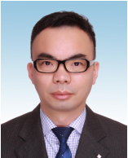
冯远静, 博士、教授、博士生导师，浙江省高校中青年学科带头人。现为浙江工业大学信息工程 学院副院长，浙江省嵌入式系统联合重点实验室（浙江工业大学）副主任，浙江工业大学人工智能系系主任、 信息处理与自动化研究所所长。西安交通大学控制科学与工程博士，哈佛大学博士后、访问学者。

Title:磁共振扩散峰度成像的多中心融合研究
Abstract: 多中心磁共振成像研究中，控制设备相关的中心间差异是核心技术难题。通常，多中心采集涉及多种不同类型的混合机型 ，与采用相同或相近机型的研究相比数据存在显著的异质性。如何控制中心间的物理差异，提升同一被试在不同中心间成像结果的一致性是相关研究的难点。本次汇报，我们重点介绍浙江大学脑影像科学技术中心(CBIST)在扩散峰度成像（DKI）的跨中心融合的工作，包括基于水模和人体旅行志愿者的两方面质控，高质量多中心扩散磁共振成像的旅行志愿者公开数据集，以及跨中心数据的深度学习融合方法等。这些工作初步提示多中心数据的融合方法可以有效地提高中心间数据一致性，提高结果的准确性和可靠性。但这方面的研究还处于起步阶段，需要大量的深入探索。
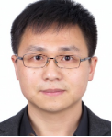
何宏建，浙江大学副教授，博士生导师。2011年获浙江大学博士学位（导师唐孝威院士）。2008年10月至2010年3月，参加国家公派项目赴加州大学圣地亚哥分校访问学习18个月。2011年至2013年，浙大光电系博士后（合作导师刘华锋教授）。2013年进入浙大生仪学院参与筹建浙江大学脑影像科学技术中心(CBIST)，并工作至今。2015年底晋升为副教授，并获硕士生和博士生导师资格。2019年12月至2020年3月，赴斯坦福大学进行深度教学研修。
近年主要关注大脑的高级磁共振成像新技术研究，及相关临床辅助应用。已发表论文30余篇，其中以第一或通讯作者SCI论文近20篇，国家发明专利7项，软件著作权2项。近五年主持国家自然科学基金2项，负责科技部重点研发计划课题1项，国防预研及其他企业科研项目7项。现为IEEE/ISMRM/OCSMRM等多个学会会员，浙江省神经科学学会心理与行为分会常务委员，中国认知科学学会神经与精神影像专业委员会、中国卫生信息与健康医疗大数据学会康复专业及信息化标准委员会、中国康复医学会脑功能检测与调控康复专委会等多个专业学会委员。
Title:3D Slicer软件在神经外科临床应用体会
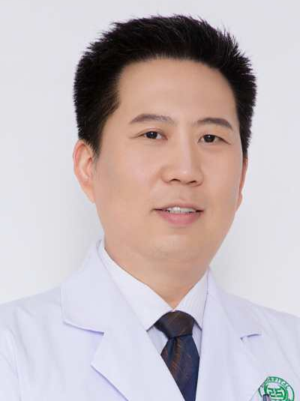
Abstract: 结合神经外科临床实际病例，简单介绍医学可视化软件3D Slicer在神经外科临床中的应用，主要包括脑内血肿三维结构重建、脑内病变定位、虚拟内窥镜、脑白质纤维束示踪及多模态手术计划等部分。
谢国强，西安交通大学外科学医学硕士，副主任医师，陕西省核工业二一五医院神经 重症卒中监护病区副主任，陕西省保健协会神经外科分会委员、陕西省保健协会急诊创伤重症委员会委员、美国哈佛医学院Brigham and Women’s Hospital(BWH)医院Surgical Plan Laboratory(SPL)访问学者。
Title:Director Field Analysis (DFA) To Quantify Local Orientational Distortion of White Matter
Abstract: In diffusion MRI, some popular scalar indices (e.g., fractional anisotropy, mean diffusivity, orientation dispersion) have been widely used in data analysis. However, these intra-voxel indices cannot represent inter-voxel local geometric structures of white matter. In a local spatial region, typical geometric structures of fiber tracts include splay (aka diverge, converge, or fanning), bend, twist, etc. In this talk, we will introduce our recent work, called director field analysis (DFA) with novel scalar indices, to quantify local orientational distortion of white matter (orientational dispersion, splay, bend and twist). The proposed DFA framework works for both voxel data (i.e., tensor images, or ODF images) and fiber tracts. We will demonstrate the test-retest reliability of DFA indices, and demonstrate some results of DFA in synthetic and real data.
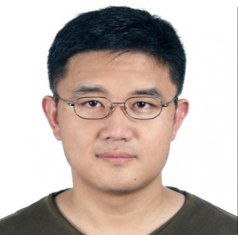
程健 博士，北京航空航天大学计算机学院和大数据精准医疗高精尖中心“医工百人”特聘副研究员。2005本科毕业于哈尔滨工业大学，2012年博士毕业于中科院自动化所和法国信息自动化所（INRIA）。曾分别在美国北卡罗来纳大学，美国国立卫生研究院，澳大利亚悉尼大学从事研究工作。主要研究领域为医学图像和信号处理、机器学习、计算机视觉、应用数学。在IEEE TMI, TCYB，Medical Image Analysis, NeuroImage, Human Brain Mapping, MICCAI, IPMI, CVPR等领域内重要期刊和会议发表30多篇论文，其中第一或通讯作者18篇。研究开发的弥散磁共振数据采集算法被美国人脑连接组计划（Human Connectome Project）采用作为其弥散磁共振数据的采集标准。曾获得中法博士联合培养奖学金，MICCAI会议最佳审稿人奖。

Title:Gyral Bias in Cortical Tractography
Abstract: Diffusion magnetic resonance imaging (DMRI) is a powerful imaging technique for non-invasive quantification of tissue microstructure and mapping of axonal trajectories by probing the diffusion patterns of water molecules in the living human brain. DMRI-based connectomics is widely used for understanding neurological development associated with the cerebral cortex. A white matter (WM) fiber tract is a collection of axons in the central nervous system with common origin and destination sites, typically in the cortical gray matter (GM). These tracts have long range and involve axons traversing from cortical GM sites through the superficial WM, then the deep WM, and into a distant cortical or subcortical structure. For an accurate connectivity map of the brain, estimated fiber streamlines must be able not only to follow major fiber bundles through the deep WM, but must also correctly follow axonal trajectories as they cross the WM-GM boundary. However, it is shown that up to 70% of the streamlines produced by the state-of-the-art tractography algorithms actually do not reach the GM, even with high angular resolution diffusion imaging (HARDI). This can be attributed to the complexity of fiber arrangement in the superficial WM, which resides beneath the cortical sheet. This in turn causes gyral bias, with streamlines preferentially terminating at gyral crowns rather than sulcal banks. Gyral bias stems from the technical difficulties in tracing highly-curved axonal trajectories across WM-GM boundaries in gyral blades. The shortcomings of existing tractography algorithms may lead to severe bias in connectivity analysis.
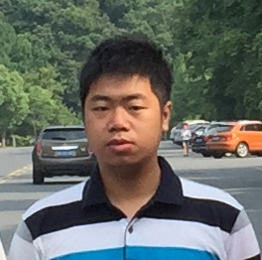
吴烨，(美国)北卡罗莱纳州大学生物医学研究影像中心博士后研究员，主要研究方向为神经科学与人工智能。已发表学术论文50余篇, 学术引用量超过580余次。医学图像顶级期刊“Medical Image Analysis” (JCR TOP, IF:8.79) 最佳论文奖(亚军)。以第一作者Oral发表研究成果在国际医学图像顶级会议, 包括IPMI, MICCAI, ISBI, ISMRM.

Title: Joint RElaxation-Diffusion Imaging Moments (REDIM) to probe neurite microstructure
Abstract: Multi-dimensional images techniques provide rich information to investigate the microscopic organizations of biological tissue. Deriving meaningful indices from imaging data is important to make these techniques in clinical research. This talk introduces a general framework, named REDIM, to estimate the moments of joint probability distribution of multi-dimensional imaging parameters. This method can be applied to analyze joint T2-diffusion, T1-diffusion and T1-T2-diffusion MRI to derive novel indices and enhance diffusion tractography results. The performance of this method is illustrated using in vivo data.
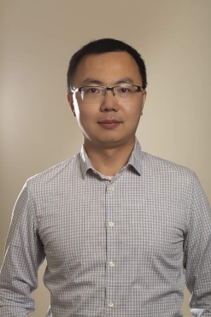
Lipeng Ning, Dr. Ning received his Ph.D. degree from the Department of Electrical and Computer Engineering, University of Minnesota. He received his B.S. and M.S. from Beijing Institute of Technology. He is currently an Assistant Professor at the Department of Psychiatry, Brigham and Women’s Hospital, Harvard Medical School. His research interest lies in developing imaging techniques to improve clinical research on brain diseases such as depression and schizophrenia. He is particularly interested in applying control theory, machine learning and signal processing techniques to solve problems in medical imaging.

Title: Novel Analyses of Diffusion MRI Fiber Tractography to Study the Brain’s Connections in Health and Disease

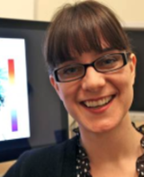
Lauren Jean O'Donnell, Ph.D. is an Associate Professor in Radiology at Harvard Medical School and Brigham and Women's Hospital. Her research focuses on diffusion magnetic resonance imaging, the only method that can map the connections of the living human brain. Her group has several research areas of interest: novel computational methods, white matter atlases, neurosurgical planning, and open-source software.

