任宏亮  工作部门:信息工程学院\光纤通信与信息工程研究所  性 别:男  技术职称:高校副教授  最高学位:博士  民 族:汉族  籍 贯:河南省
  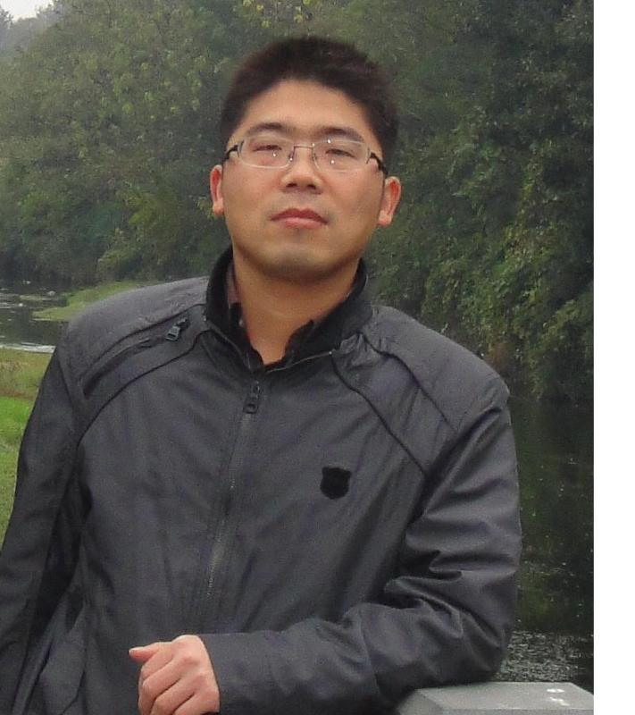
浙江工业大学信息工程学院光纤通信与信息工程研究所所长。先后发表SCI、EI等收录期刊论文70余篇。主持国家、省部级科研项目多项。授权发明专利10余项。入选浙江省中青年学科带头人计划支持。
目前研究兴趣：
1、人工智能与光传感
2、模拟光子计算
近年研究论文列表：
(1) Yulu Zhang, Jin Lu, Zichun Le, Chunhua Dong, Huan Zheng, Yali Qin, Peiqiong Yu, Weisheng Hu, Chang-Ling Zou, Hongliang Ren*, Proposal of unsupervised gas classification by multimode microresonator, IEEE Photonics Journal, 13(2), 3069582 (2021). (SCI, IF 2.833)

(2) Jin Lu, Rui Niu, Shuai Wan, Chun-Hua Dong, Zichun Le, Yali Qin, Yingtian Hu, Weisheng Hu, Chang-Ling Zou and Hongliang Ren*，Experimental demonstration of multimode microresonator sensing by machine learning, IEEE Sensors Journal 21(7), 9046-9053 (2021). (SCI, IF 3.073)
(3) Dong Hu, Chang-Ling Zou, Hongliang Ren*, Jin Lu, Zichun Le, Yali Qin, Shuqin Guo, Chun-Hua Dong and Weisheng Hu, Multi-parameter sensing in a multimode self-interference micro-ring resonator by machine learning, Sensors, 20(3), 709 (2020). (SCI, IF 3.427)

(4) Binqi Wu, Jin Lu*, Mingyi Gao, Hongliang Ren, Zichun Le, Yali Qin, Shuqin Guo and Weisheng Hu, Time-domain blind ICI compensation in coherent optical FBMC/OQAM system, Sensors 20(21), 6397 (2020). (SCI, IF 3.427)

(5) Hongliang Ren*, Chang-ling Zou, Jin Lu, Zichun Le, Yali Qin, Shuqin Guo and Weisheng Hu, Dissipative sensing with low detection limit in a self-interference micro-ring resonator, Journal of the Optical Society of America B, 36(4), 942-951 (2019). (SCI, IF 2.284)
(6) Ping Zhang, Hongliang Ren*, Mingyi Gao, Jin Lu, Zichun Le, Yali Qin and Weisheng Hu，Low-complexity blind carrier phase recovery for C-mQAM coherent systems, IEEE Photonics Journal, 11, 7200214 (2019). (SCI, IF 2.729)

(7) Hongliang Ren*, Pu Yu, Jin Lu, Mingyi Gao, Zichun Le, Yali Qin, Shuqin Guo and Weisheng Hu， Fast statistical estimation with vector quantization in compressed digital RoF systems, Applied optics, 58(13), 3418-3425(2019). (SCI, IF 1.973)

(8) Hongliang Ren*, Chang-Ling Zou, Jin Lu, Lin-Lin Xue, Shuqin Guo, Yali Qin and Weisheng Hu, Highly-sensitive intensity detection by a self-interference micro-ring resonator, IEEE Photonics Technology Letters, 28, 1469-1472 (2016). (SCI, IF 2.553)

本人真诚欢迎愿意来浙江工业大信息学院 学习人生有意义的事，不放弃，不抛弃！！！

联系方式： E-mail: hlren@zjut.edu.cn 0571 - 85290605 (office)

