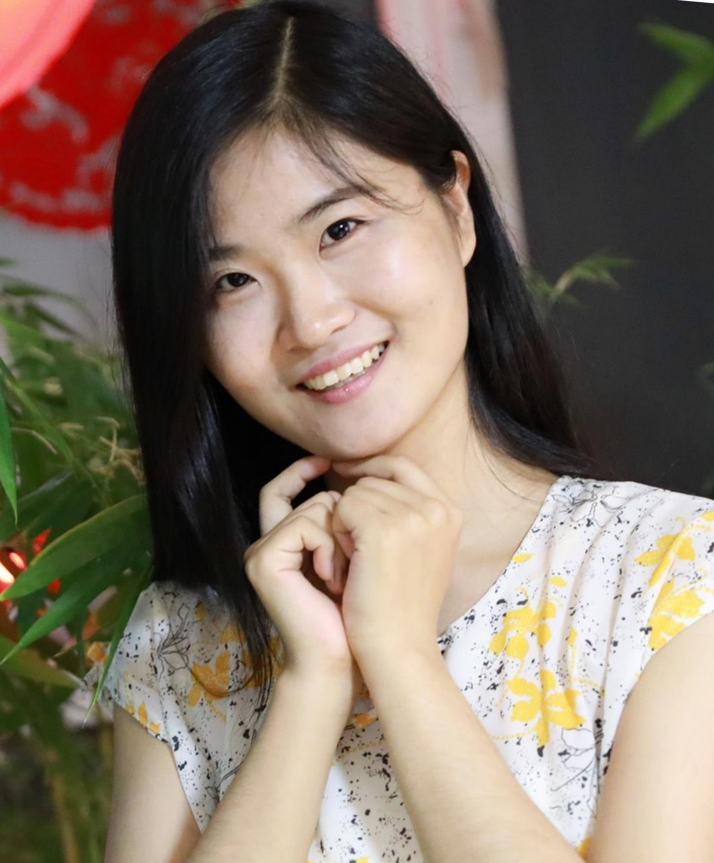
姓 名：胡映天
工作部门：信息工程学院
性 别：女
技术职称：讲师
最高学位：博士
民 族：汉
籍 贯：吉林省
联系方式：13082823552
Email: huyt@zjut.edu.cn

主要研究方向：
基于先进光电技术的智慧水环境监测
传统的水质监测技术具有耗时长、产生二次污染等问题，不利于大面积布放及实时预警。课题组自2014年开始研究基于先进光电技术的实时、无污染水质监测方案及仪器，先后承担了多项国家级、省级项目，发表多篇领域内顶级期刊论文。目前，课题组正在向多参数、新算法、新仪器、融合5G通信、图像算法、深度学习等方面拓展，欢迎有志为我国环保事业做贡献的同学报考。

简 历：
胡映天，女，1991年生，吉林省吉林市人。浙江大学光学工程专业博士毕业，现于浙江工业大学信息学院任教。共发表SCI/EI论文二十余篇，以第一作者身份发表高水平论文9篇，包括领域内TOP期刊Water Research、Sensors and Actuators B等。主持国家自然科学基金项目1项，作为骨干成员参与国家863项目1项。

研究（情况）项目：
近年来的研究工作主要围绕多源光谱联合技术、水污染早期溯源分析与预警、水质参数测量与光学信息挖掘等展开。包括以下项目：
基于吸收-荧光光谱机理性特征挖掘的水质溯源分析方法研究，国家自然科学基金，2021.1-2023.12（主持）
基于多维光谱信息挖掘的水体COD测量方法研究，公司委托项目，2019.10-今（主持）

发表的论文、专著、教材：
[1]YT, Hu, DD Zhao, YL Qin, An enhancement approach of fluorescence signatures in excitation emission matrixes for water contaminant analysis, Water Research, 2020, 169. (TOP期刊，影响因子为9.1)
[2]YT Hu, XP Wang, Application of surrogate parameters in characteristic UV–vis absorption bands for rapid analysis of water contaminants, Sensors and Actuators B: Chemical, 239(2017) 718-726 ( TOP期刊，影响因子为7.1)
[3]YT Hu, YZ Wen, XP Wang, Novel method of turbidity compensation for chemical oxygen demand measurements by using UV–vis spectrometry, Sensors and Actuators B: Chemical, 227 (2016) 393-398 ( TOP期刊，影响因子为7.1)
[4]YT Hu, HD Zhang, DD Zhao, Transform method in three-dimensional fluorescence spectra for direct reflection of internal molecular properties in rapid water contaminant analysis, Spectrochimica Acta Part A: Molecular and Biomolecular Spectroscopy, 2021, 250. (JCR一区，影响因子为3.2)
[5]YT Hu, DD Zhao, YL Qin, An order determination method in direct derivative absorption spectroscopy for correction of turbidity effects on COD measurements without baseline required, Spectrochimica Acta Part A: Molecular and Biomolecular Spectroscopy, 2020, 226. (JCR一区，影响因子为3.2)
[6]YT Hu, C Liu, XP Wang, DD Zhao, Adaptive handling of Rayleigh and Raman scatter of fluorescence data based on evaluation of the degree of spectral overlap, Spectrochimica Acta Part A: Molecular and Biomolecular Spectroscopy, 199(2018) 170-178 (JCR一区，影响因子为3.2)
[7]YT Hu, XP Wang, Detection of water quality multi-parameters in seawater based on UV-Vis spectrometry, OCEANS2016–Shanghai, IEEE
[8]YT Hu, C Liu, XP Wang, DD Zhao, Novel feature extraction method for rapid analysis of watercontaminants based on three-dimensional fluorescence and absorption spectroscopy, Proceedings of the SPIE, 2018
[9]YT Hu, XP Wang, Novel Local Calibration Method for Chemical Oxygen Demand Measurements by Using UV-Vis Spectrometry, IOP Conference Series: Earth and Environmental Science, 2017, 63 (1) 012016
[10] M Lv, YT Hu, Novel Spectral COD Measurement Method based on Identification of Water Samples, Spectroscopy and Spectral Analysis, 2017, 37(12)3797-3802
[11] Z Shi, YT Hu, Design of in-situ Chlorophyll-a Sensor for Water Based on Dual-Path Fluorescence Intensity Method,Chinese Journal of Sensors and Actuators, 2019, 32(5), 687, 670-5
[12]DD Zhao, P Chen, YT Hu, RH Liang, Synthesis of sparse planar arrays in the whole field by compressed sensing, ELECTRONICS LETTERS, 2019, 55(23), 1211-1212
[13]XX Liu, YL Qin, KL Ji, YT Hu, Rotation and oscillation of gap vortex solitons in optically induced square photonic lattices with a self-focusing nonlinearity,LASER PHYSICS, 2021, 31(4)
[14]DD Zhao, XS Liu, F Zhou, YT Hu, Design of portable three-dimensional sonar for both far-field and near-field, Journal of Zhejiang University. Engineering Science, 2019, 53(2), 364-372
[15]C Liu, YT Hu, XP Wang, Research on marine plankton imaging based on digital holographic technology, Proceedings of the SPIE, 2018
[16]C Liu, YT Hu, XP Wang, An approach for sensing underwater particles using digital holographic imaging, Proceedings of the SPIE, 2018
[17]YZ Wen, YT Hu, XP Wang, Application of a colorimeter for turbidity measurement, Journal of Physics: Conference Series, 2016, 679(1), 012028 2016
[18]ZG Tao, YT Hu, XP Wang, A new biometric system based on inner-knuckle-print recognition, IOP Conference Series-Earth and Environmental Science, 2018
[19]Z Shi, C Liu, YT Hu, In-site chlorophyll-a fluorometer based on lock-in amplifier, Proceedings of the SPIE, 2018
[20]DD Zhao, XS Liu, TY Hu, An Efficient Near-Field Parallel Subarray Beamforming for Portable 3D Imaging Sonar, 2018 IEEE 3rd
[21]H Chen, YL Qin, HL Ren, LP Chang, YT Hu, H zheng, Adaptive Weighted High Frequency Iterative Algorithm for Fractional-Order Total Variation with Nonlocal Regularization for Image Reconstruction, ELECTRONICS, 2020, 9(7)
[22]JP FENG, YL Qin, YY Wang, Z Huan, HL Ren, YT Hu, Defect solitons supported by two-dimensional lattice potentials in biased centrosymmetric photorefractive crystals with saturable self-focusing nonlinearity, LASER PHYSICS, 30(6)
科研成果及专利：
- 胡映天，覃亚丽，赵冬冬. 用于COD测量中的浊度干扰消除方法.申请号: CN201910985614.2，公开时间: 2020.2.21
- 王晓萍，胡映天，文一章.一种基于紫外吸收光谱法的水质趋势预测方法.专利号: CN201510782535.3, 授权时间: 2018.1.23
- 王晓萍，胡映天，文一章.一种基于光谱法COD检测的浊度补偿方法.专利号: CN201510661778.1, 授权时间: 2018.1.23
- 王晓萍，文一章，胡映天. 一种基于色坐标值的水溶液浊度测量方法及装置.专利号: CN201610059925.2, 授权时间: 2018.10.12
- 王晓萍，吕蒙，高亚，文一章，胡映天.一种基于水样类型识别的水体COD光学测量方法.专利号: CN201510346798.X, 授权时间: 2018.1.23

研究生培养等教学情况：
研究生培养情况：目前指导研究生1名；
教学情况：主讲本科生课程《面向对象C++编程》、《程序设计基础C》。

奖励和荣誉：
无

其它：
无

